Atoms & Molecules
A taxonomy for a compositional report is a diagram that shows parts of a whole.
- Read each paragraph.
- Highlight the nouns (things and names of things).
- Then fill in the taxonomy diagram to show the whole and the parts and sub-parts.
The air in the atmosphere is a mixture of different gases that is constantly changing.
Nitrogen makes up 78% of the air. The oxygen we breathe makes up 21% of the air.
Another gas called argon is less than 1% of the air. Carbon dioxide is around 0.03%. Small amounts of other gases make up the remaining parts.
Air

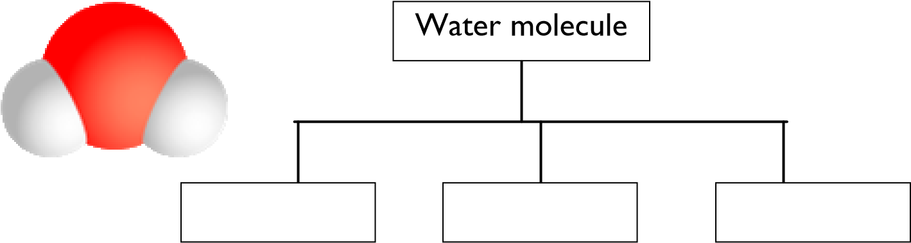
Water is made up of molecules. It is a compound of hydrogen and oxygen atoms. Each molecule of water contains two atoms of hydrogen and one atom of oxygen.
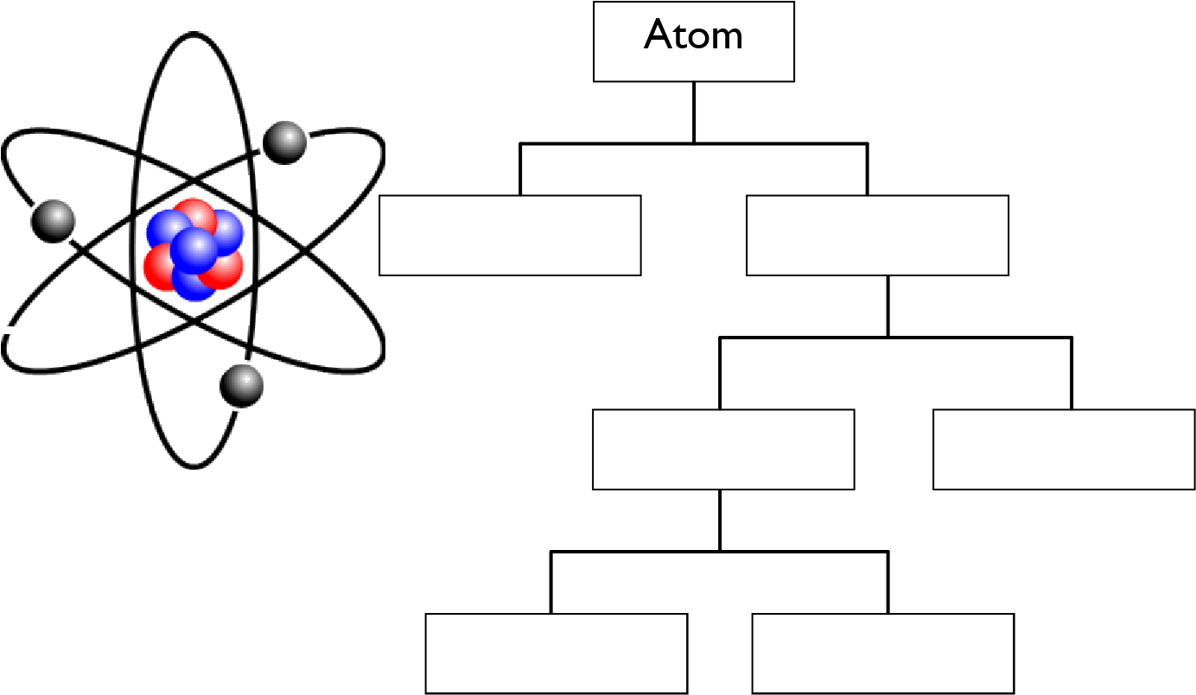
An atom is a tiny particle made up of even tinier particles. In the centre of each atom there is a
nucleus. Inside the nucleus, there are protons and neutrons. Electrons whiz around the nucleus, like planets orbiting the sun. There are even smaller
particles inside the nucleus. A neutron is made up of tiny particles called quarks held together with other particles called gluons.

